SIRI M
1VI23CD055

TABLEAU ASSIGNMENT – QUESTION 20

CATEGORY-SUPERSTORE_USA REPORT
Dataset Used: Superstore_USA
Tool Used: Tableau Desktop / Public
Visualization Created: Donut Chart – Total Sales by Product Category, Side-by-Side Bar Chart – Sales by Region and Category, Scatter Plot – Sales vs Profit by Sub-Category, Line Chart – Sales Trend over Years by Category, Filled Map – Sales Distribution by State.
Objective:
To analyze the Superstore_USA dataset by creating different types of visualizations that highlight composition, comparison, relationships, trends, and geographic distribution of sales. This helps in understanding sales patterns, category performance, and regional insights for better business decision-making.
Steps Implemented:
- Data Import
- Opened Tableau Desktop.
- Connected to the Excel file Superstore_USA.
- Verified that fields such as Sales and Product Category were correctly detected.

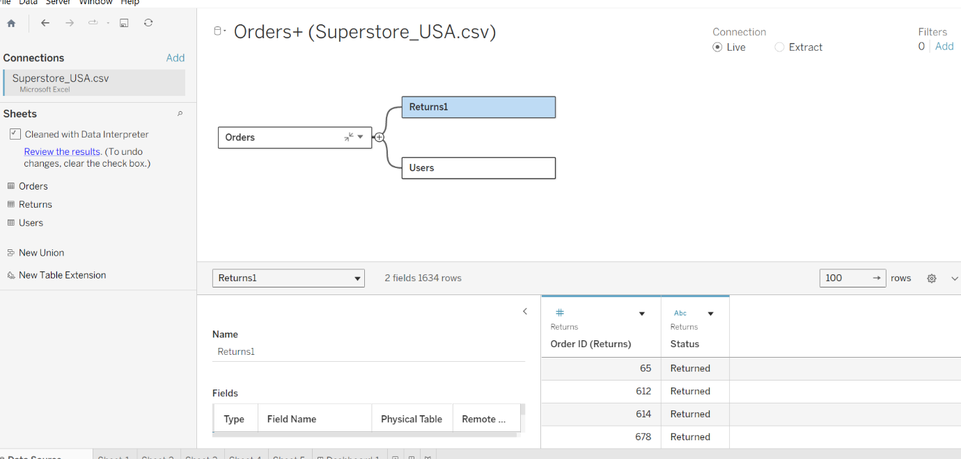
2.Composition – Stacked Bar / Pie Chart
Steps:
- Open Tableau → Connect to Superstore_USA.xlsx.
- Drag Category → Columns.
- Drag Sales → Rows.
- Drag Sub-Category → Color.
- Click Show Me → select Stacked Bar Chart (or Pie Chart).
- Add Sales labels on each segment (right-click → Show Mark Labels).
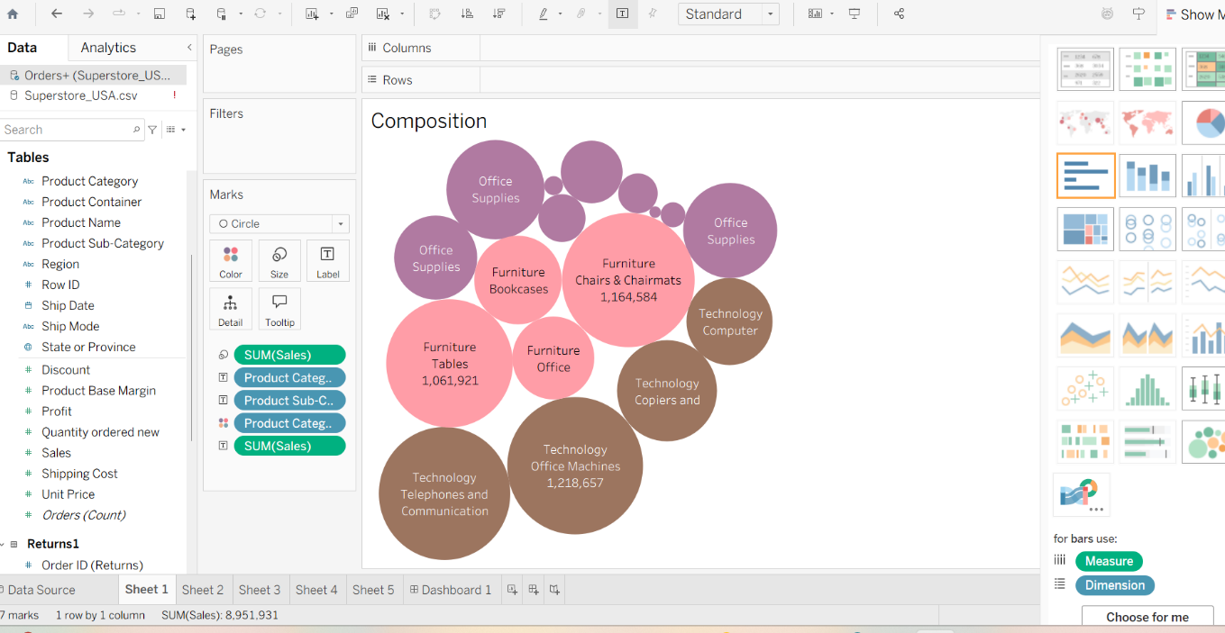
3.Comparison – Side-by-Side Bar Chart
Steps:
- Drag Region → Columns.
- Drag Sales → Rows.
- Drag Category → Color.

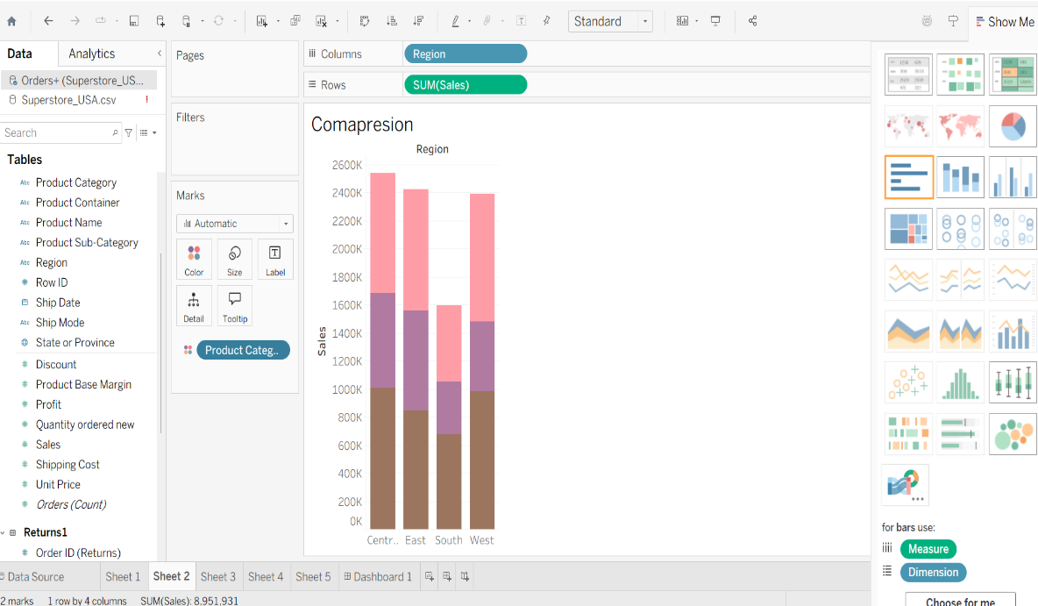

4.Relation – Scatter Plot
Steps:
- Drag Sales → Columns.
- Drag Profit → Rows.
- Drag Category → Color.
- Drag Product Name → Detail (optional for hover).
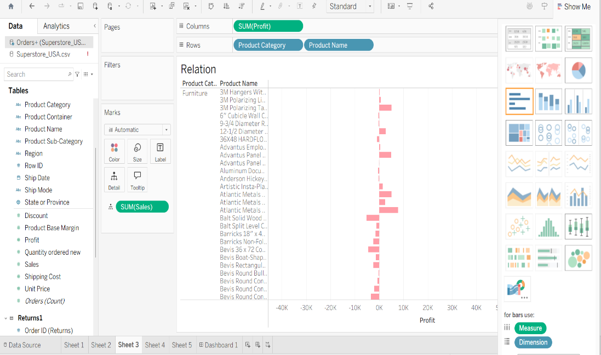

5.Trend – Line Chart
Steps:
- Drag Order Date → Columns (choose Year).
- Drag Sales → Rows.
- Drag Category → Color.
- Optional: Drag Profit → Rows (dual-axis) if needed.

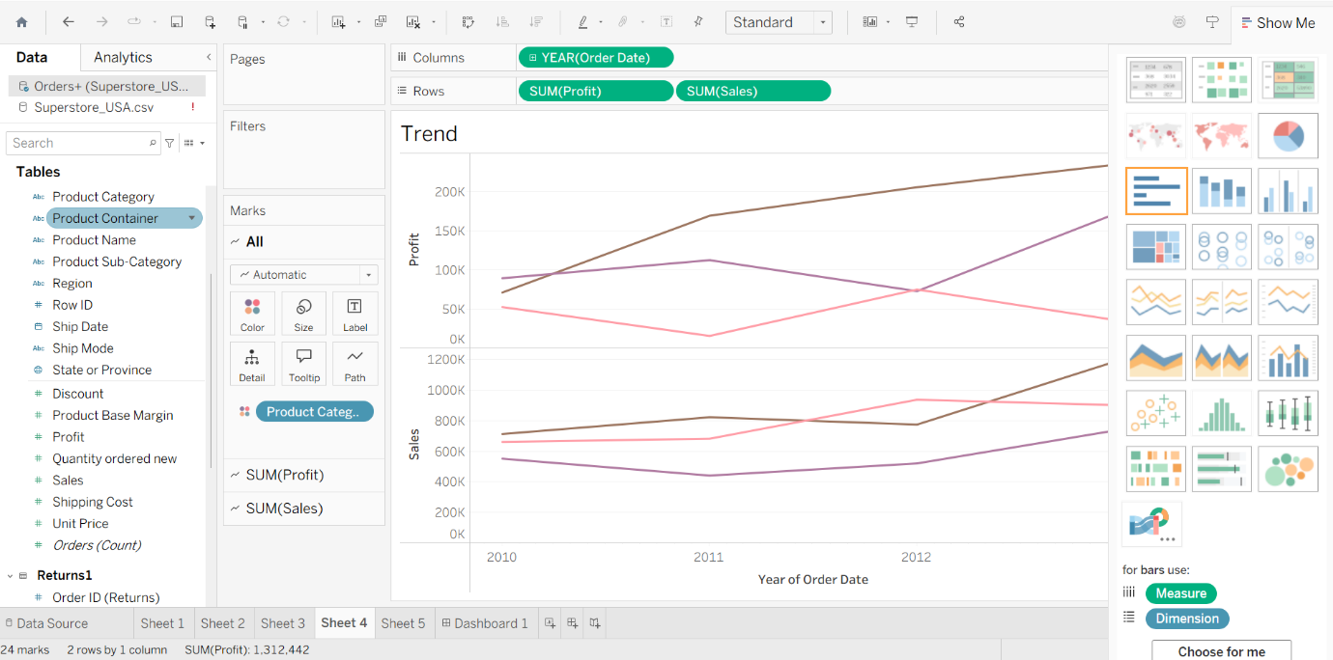
6.Geo Maps – Filled Map
Steps:
- Drag State → Rows (Tableau creates a map).
- Drag Sales → Color.
- Optional: Drag Profit → Size.
- Hover over states to show values.

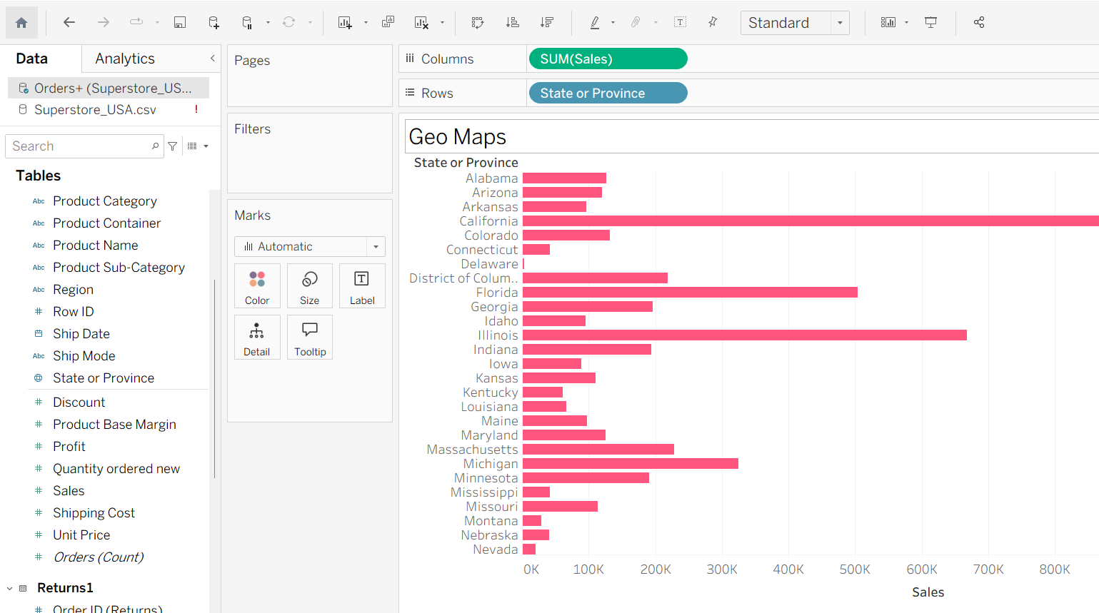

Final Dashboard:
Steps:
- Create a new Dashboard.
- Drag all 5 worksheets onto the dashboard.
- Adjust size and layout for clarity.
- Add filters for Category or Region for interactivity.

